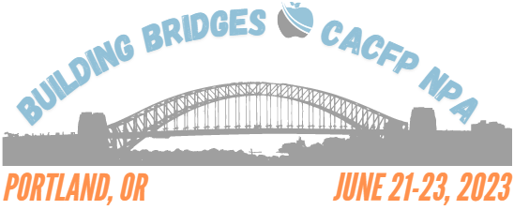
DoubleTree Hilton Hotel
1000 NE Multnomah St, Portland, OR 97232

One registration form per registrant. Registration Deadline: April 28, 2023
NAME:
TITLE:
ORGANIZATION:
ADDRESS:
CITY/STATE/ZIP:
OFFICE PHONE: |  | CELL PHONE:
E-MAIL:

Please select the ONE Conference Registration category that applies to you:
Wednesday-Friday Current CACFP NPA Member $ 350.00
Wednesday-Friday CACFP NPA Non-Member SA Staff $ 430.00*
Thursday & Friday USDA & Partner Organization Staff $ 235.00
*includes CACFP NPA Membership for remainder of FY2023

Please select the ONE Method of Payment that applies to you:
Credit Card. Online at http://www.cacfpnpa.org/. The registration form may be submitted by fax or e-mail to Christopher.Felts@health.ny.gov .
Check. If paying by mail, send check or money order (payable to CACFP National Professional Association) along with the registration form(s) to:
CACFP National Professional Association
c/o Chris Felts, Treasurer Phone: (800) 942-3858 (option2)
NYS DOH Child & Adult Care Food Program Fax: (518) 402-7252
150 Broadway Suite 600 FEIN: 45-0440145
Albany, NY 12204

No refunds will be made after May 5, 2023

For more conference related information and the link to conference host hotel booking, please visit the NPA Conference webpage.

